Module 6: Critical Thinking

Alexander Vollen
Colorado State University Global
MIS581: Principles of Machine Learning
Steve Chung
March 29th, 2026

Module 6: Critical Thinking
Introduction
Trade between the United States and Canada is one of the most deeply integrated economic relationships in the world. Canada’s merchandise exports to the United States account for roughly three-quarters of its total exports and are equivalent to nearly one-quarter of the Canadian GDP, making the country uniquely vulnerable to disruptions in this relationship (Towe, 2025). When tariff policy shifts, the effects extend well beyond trade balances, touching all parts of the supply chain. Such as manufacturers, workers, distributors, and consumers on both sides of the border across interconnected supply chains in steel, aluminum, automotive, and other industries.
Recent tariff actions have raised the importance of understanding how these policy shifts produce statistically detectable changes in bilateral trade volumes, specifically whether Canada’s imports from the United States declined, whether sourcing shifted to non-U.S. suppliers, and whether Canada’s exports to the United States weakened in the most tariff-exposed sectors of the economy. These questions matter because the answers are not as obvious as they might appear, even when tariffs are clearly in place. A decline in imports from the United States does not automatically mean that tariffs caused demand to fall. If imports from the United States drop while imports from non-U.S. countries rise for the same tariff-exposed product categories, the more likely explanation is trade diversion, a shift in sourcing driven by cost pressure tariffs create rather than a reduction in overall demand. If imports decline across all supplier countries for those same products, that points toward a broader demand slowdown that tariffs alone may not fully explain. Complicating both interpretations are factors such as exchange rate movements, inflation, seasonal demand cycles, supply chain disruptions, and broader economic conditions that can shift trade amounts independently of tariff policy. For this reason, the results of this analysis are presented as evidence of an association between tariff periods and trade outcomes rather than definitive proof of causation. Distinguishing between these possible explanations leads to different strategic and organizational responses, which is precisely why a data-driven approach is necessary rather than relying on assumptions. It is also important to note that this research does not attempt to fully account for overall demand shifts or all variables that influence trade; it is focused specifically on comparing trade volumes during tariff-active periods against non-tariff periods for a defined set of product categories. This is one focused piece of a much larger and more complex trade equation.
The tariff environment between the United States and Canada has gone through two distinct episodes that shape this analysis. In March 2018, the United States applied Section 232 tariffs to Canadian steel and aluminum products, and Canada responded with countermeasures covering C$16.6 billion in U.S. imports (Canada, Department of Finance, 2025a). Those tariffs were mutually removed in May 2019, though uncertainty remained even after the episode ended. The Canada-United States-Mexico Agreement entered into force on July 1, 2020, providing the current framework for trade between the two countries. A second wave of tariff escalation began in March 2025, and while most of those measures were removed on September 1, 2025, duties on steel, aluminum, and automobiles remained active (Canada, Department of Finance, 2025b). These two episodes define the tariff-active periods used in this analysis and are the reason steel, aluminum, and automobiles were selected as the three sector groups for study. The steel group includes HS codes 720825, 720851, 720916, 721070, and 721310, covering flat-rolled steel products and steel bars and rods. The aluminum group includes HS codes 760110, 760120, 760421, 760612, and 760711, covering unwrought aluminum, profiles, sheet, and foil products. The automobile group includes HS codes 870323, 870324, 870421, 870840, and 870899, covering passenger vehicles, light-duty trucks, transmission systems, and motor vehicle parts. Together, these 15 codes represent the core tariff-exposed products across the three sectors and form the basis of all analysis conducted in this project.
The purpose of this study is to examine whether the two tariff episodes produced statistically detectable changes in trade flows for these 15 tariff-exposed HS codes across the steel, aluminum, and automobile sectors. Using monthly trade data from the U.S. International Trade Commission and Statistics Canada spanning January 2012 through January 2026, this analysis compares trade volumes during tariff-active periods against non-tariff periods to test three research questions and their associated hypotheses. The study draws on descriptive statistics, Mann-Whitney U testing, and ordinary least squares regression to evaluate whether Canada's imports from the United States declined, whether trade diverted to non-U.S. suppliers, and whether Canada's exports to the United States weakened during tariff periods. In addition, a predictive forecast is developed to project how trade volumes in these sectors may trend under two scenarios, one in which current tariffs remain in place and one in which they are removed, providing a forward-looking perspective to complement the historical analysis. The findings are intended to give organizations, analysts, and policymakers a cleaner, evidence-based picture of how tariff policy has moved the needle on cross-border trade in these sectors, not as a definitive explanation of all forces at play, but as a focused and transparent look at one important piece of a complex trade relationship.
Objectives
The objectives of this study are directly tied to the research questions and the broader problem of understanding how tariff policy affects cross-border trade patterns between the United States and Canada. The first objective is to measure whether Canada's average monthly imports from the United States declined during tariff-active periods compared to non-tariff periods for the selected steel, aluminum, and automobile HS code groups. The second objective is to determine whether Canada increased imports of those same product categories from non-U.S. countries during tariff periods, which would indicate trade diversion rather than an overall demand reduction. The third objective is to examine whether Canada's exports to the United States weakened during tariff periods for the same product groups, providing a view of how tariff conflict may affect trade in both directions. Beyond hypothesis testing, a fourth objective is to develop a predictive forecast that projects how trade volumes in these sectors may trend under two scenarios, one where the current tariff remains in place and one where they are removed, to provide a forward-looking perspective for decision makers. Together, these objectives are designed to produce a transparent, repeatable analysis that gives organizations and policymakers an evidence-based foundation for understanding tariff impacts rather than relying on assumptions or headline-level interpretations.
Overview of Study
This study examines the trade relationship between the United States and Canada during two distinct tariff episodes, using product-level monthly trade data to test whether tariff-active periods are associated with statistically detectable changes in cross-border trade flows. The analysis is organized around 15 tariff-exposed HS codes grouped into three sector clusters: steel, aluminum, and automobiles. These sectors were selected because they represent the product categories that remained subject to active Canadian counter-tariffs after September 1, 2025, making them the most policy-relevant groups for current analysis.
Three datasets form the foundation of this study. The first is U.S. exports to Canada by HS code and month, sourced from the U.S. International Trade Commission DataWeb, covering January 2012 through January 2026. The second is Canada's imports from all countries by HS code, sourced from Statistics Canada Trade Data Online, which allows U.S. and non-U.S. import values to be separated and compared. The third is U.S. imports from Canada by HS code and month, also sourced from the U.S. International Trade Commission DataWeb, which serves as a proxy for Canada's exports to the United States. Together these three datasets make it possible to examine trade flows from multiple directions and test whether tariff periods are associated with changes in sourcing patterns, import volumes, and export activity.
The study defines two tariff-active periods based on official policy announcements. The first covers March 2018 through April 2019, corresponding to the Section 232 steel and aluminum tariffs and Canada's retaliatory countermeasures. The second covers March 2025 onward, corresponding to the 2025 tariff escalation and the continuation of duties on steel, aluminum, and automobiles after September 1, 2025. All remaining months from January 2012 through the end of the dataset are coded as non-tariff periods, providing a long historical baseline that captures normal seasonality, demand cycles, and trade volatility prior to and between the two episodes.
The analytical approach begins with descriptive statistics to summarize average monthly trade values, total trade volumes, and variability by sector group and tariff period. Trend charts are used to visualize how trade flows moved over time relative to the tariff timeline. Mann-Whitney U tests are then applied to compare trade values between tariff-on and tariff-off periods for each research question and sector group, as this non-parametric test does not require the data to be normally distributed, which is appropriate given the skewed nature of monthly trade data. Ordinary least squares regression is also used to estimate the association between tariff periods and trade values while controlling for sector differences. Finally, a predictive forecast is developed using historical trend data to project trade volumes under two forward-looking scenarios, one assuming current tariffs remain in place and one assuming they are removed.
This study does not attempt to establish definitive causation between tariff policy and trade outcomes, nor does it account for all variables that influence trade volumes. Factors such as exchange rate movements, inflation, supply chain disruptions, and broader macroeconomic conditions can all affect trade independently of tariff policy. The results are therefore interpreted as evidence of association between tariff periods and trade outcomes, representing one focused and transparent piece of a much larger and more complex trade equation.
Research Questions and Hypotheses
This study is organized around three research questions, each tested across the steel, aluminum, and automobile sector groups.
RQ1: For selected tariff-exposed steel, aluminum, and automobile HS code groups, did Canada's average monthly imports from the United States decline during tariff periods compared with non-tariff periods?
H0₁: There is no statistically significant difference in the average monthly value of Canada's imports from the United States for the selected steel, aluminum, and automobile groups during tariff periods compared with non-tariff periods.
H1₁: The average monthly value of Canada's imports from the United States for the selected steel, aluminum, and automobile groups is lower during tariff periods than during non-tariff periods.
RQ2: For those same tariff-exposed groups, did Canada's average monthly imports from non-U.S. countries increase during tariff periods compared with non-tariff periods?
H0₂: There is no statistically significant difference in the average monthly value of Canada's imports from non-U.S. countries for the selected steel, aluminum, and automobile groups during tariff periods compared with non-tariff periods.
H1₂: The average monthly value of Canada's imports from non-U.S. countries for the selected steel, aluminum, and automobile groups is higher during tariff periods than during non-tariff periods.
RQ3: For those same tariff-exposed groups, did Canada's exports to the United States decline during tariff periods compared with non-tariff periods?
H0₃: There is no statistically significant difference in the average monthly value of Canada's exports to the United States for the selected steel, aluminum, and automobile groups during tariff periods compared with non-tariff periods.
H1₃: The average monthly value of Canada's exports to the United States for the selected steel, aluminum, and automobile groups is lower during tariff periods than during non-tariff periods.
Literature Review
The literature supporting this research covers historical trade policy analysis, simulation-based modeling, and empirical economic research, all of which connect to the core questions of how tariffs affect cross-border trade flows between the United States and Canada.
Trade between the two countries has long been shaped by policy decisions that carry real economic consequences on both sides of the border. Canada and Mexico's exports to the United States account for over 20% of their respective GDP, making both economies especially exposed to shifts in U.S. trade policy (May, 2025). Research modeling extreme tariff scenarios projects that Canada could experience GDP losses of nearly 4.5% below baseline under a targeted 25% tariff environment, which is the most severe projected outcome of any country analyzed in that research (May, 2025). This context reinforces why understanding the product-level effects of tariff episodes matters rather than relying on aggregate economic assumptions alone.
At the bilateral level, the interdependence between the U.S. and Canadian economies means that tariff escalation carries costs for both sides rather than producing clear winners. The high economic costs of both initial U.S. tariffs and retaliatory Canadian measures highlight how deeply connected the two economies are across major industries (Liu, 2026). This is particularly relevant to the current study because it supports the expectation that tariff periods should produce observable changes in trade data, while also reinforcing the need to avoid drawing absolute conclusions given the range of other economic forces that can influence trade volumes at the same time.
Simulation-based research using the International Trade Closeness Model finds that protectionist trade policies result in economic inefficiencies, inflationary pressures, and market distortions across agriculture, manufacturing, heavy industry, and services (Ruiz Estrada et al., 2025). The model also demonstrates a near-perfect correlation between tariff escalation and increasing trade closeness, suggesting that higher tariff barriers are strongly associated with reduced trade openness across multiple sectors (Ruiz Estrada et al., 2025). This is directly relevant to the steel, aluminum, and automobile sectors examined in this study, as those sectors showed the highest closeness scores in the model's analysis of U.S. and Canada trade patterns.
Historical empirical research on the Canada-U.S. Free Trade Agreement provides useful grounding for understanding how trade policy changes reshape economic outcomes over time. The FTA created substantial long-run productivity benefits, though the short-run worker displacement costs were also substantial (Trefler, 2001). This is relevant because it shows that trade policy changes between the two countries produce measurable sector-level effects that can be difficult to separate from broader economic trends, which is a challenge this study addresses by using a clearly defined tariff timeline and a long pre-tariff baseline period for comparison.
Together these sources support the analytical framework of this study by confirming that tariff policy between the United States and Canada has historically produced measurable trade and economic effects, while also reinforcing the importance of presenting findings as associations rather than absolute causal conclusions.
Research Design
Methodology
This study uses a quantitative research design based on secondary trade data. Quantitative methods were chosen because the research questions require numerical comparison of trade values across defined time periods, which calls for statistical testing rather than qualitative interpretation. The data are observational in nature, meaning the study does not manipulate any variables or conduct experiments, but instead analyzes patterns in existing trade records to test whether tariff periods are associated with statistically detectable differences in trade volumes.
The primary unit of analysis is the monthly trade value in U.S. dollars for each of the 15 selected HS codes, grouped into three sector clusters. Each monthly observation is coded as either a tariff-active period or a non-tariff period based on the official tariff timeline, which allows direct comparison of trade behavior under the two conditions. This design is straightforward, repeatable, and transparent.
Methods
The analytical process follows a structured sequence. Descriptive statistics are calculated first for each sector group and tariff period, including average monthly trade value, total trade value, and standard deviation. These summaries provide a baseline understanding of the data and help identify any outliers or unusual observations before hypothesis testing begins. Trend charts are also produced to visualize how trade flows moved over time relative to the tariff timeline, giving important context to the statistical results.
To test the three research hypotheses, Mann-Whitney U tests are applied to compare trade values between tariff-on and tariff-off periods for each research question and sector group. The Mann-Whitney U test was selected because it does not require the data to follow a normal distribution, which is appropriate given that monthly trade data tends to be right-skewed with occasional large outliers. This test directly answers whether trade values during tariff periods tend to be significantly higher or lower than during non-tariff periods.
Ordinary least squares regression is also applied using a tariff dummy variable coded as one for tariff-active months and zero for non-tariff months, with sector indicator variables included to control for differences across the steel, aluminum, and automobile groups. This approach estimates the association between tariff periods and trade values in a way that accounts for sector-level variation and provides a quantitative estimate of the magnitude of any detected difference.
Finally, a predictive forecast is developed using the historical pre-tariff trend as a baseline. Two scenarios are projected forward, one assuming current tariffs remain in place and one assuming they are removed, to give decision makers a forward-looking perspective grounded in the observed historical data.
Limitations
Several limitations should be considered when interpreting the results of this study. The most significant is that the Canadian import data available through Statistics Canada Trade Data Online is provided at an annual frequency for the full historical period, while monthly data is only available for the most recent 24 months. This means that the trade diversion analysis for Research Question 2 relies on annual data for the majority of the study period and monthly data only for the 2025 tariff episode. While this approach is analytically defensible and transparently documented, it does introduce a difference in granularity between datasets that should be kept in mind when comparing results across research questions.
A second limitation is that trade flows are influenced by many factors beyond tariff policy. Exchange rate movements, inflation, seasonal demand cycles, supply chain disruptions, and broader macroeconomic conditions can all shift trade volumes independently of whether tariffs are active. This study does not control for all of these variables, which means the results reflect associations between tariff periods and trade outcomes rather than isolated causal effects of tariff policy alone. Events such as the COVID-19 pandemic in 2020 and the energy market disruptions following Russia's invasion of Ukraine in 2022 are notable examples of non-tariff factors that caused significant short-term movement in trade data during the study period.
A third limitation involves data granularity. The datasets used in this study report monthly dollar values aggregated across all transactions for each HS code. More granular data showing individual shipment quantities, specific supplier identities, and unit-level pricing would allow for a more precise analysis of trade diversion and supply chain shifts. Without that level of detail, the analysis is limited to observing changes in aggregate dollar values, which can be influenced by price changes as well as volume changes.
Finally, the 15 HS codes selected for this study represent a focused subset of tariff-exposed products and do not capture the full range of goods affected by U.S.-Canada tariff policy. The findings should therefore be interpreted as representative of the steel, aluminum, and automobile sectors specifically rather than as a comprehensive picture of all tariff impacts across the broader trade relationship.
Ethical Considerations
Although this study uses publicly available trade data rather than data collected from human subjects, there are several ethical considerations worth addressing in the interest of responsible and transparent research.
The most important ethical consideration is avoiding the overstatement of findings. Trade flows can be influenced by many different factors simultaneously, and it would be irresponsible to present the results of this analysis as definitive proof that tariffs alone caused any observed changes in trade volumes. Exchange rates, inflation, supply chain disruptions, seasonal demand patterns, and broader economic conditions all play a role in shaping trade data. For this reason, findings are presented as associations between tariff periods and trade outcomes rather than absolute conclusions, and the limitations of the analysis are clearly acknowledged throughout the paper.
A second ethical consideration involves fairness in how results are presented. Tariffs and trade policy are politically charged topics, and there is a risk of bias in how data is selected, interpreted, or framed. To reduce this risk, the datasets used in this study are publicly available official sources from both the U.S. and Canadian governments, and the analytical process is documented transparently so that it can be reviewed and replicated. No data was selectively excluded to support a preferred outcome, and the results are reported regardless of whether they support or fail to support the alternative hypotheses.
A third consideration involves data quality and consistency. The U.S. and Canadian datasets use harmonized HS6 classification codes, which were carefully verified to ensure that the same product categories are being compared across both datasets. Care was also taken to ensure that all values are reported in U.S. dollars to maintain consistency across the analysis. These steps were taken to ensure that the findings reflect actual trade patterns rather than artifacts of inconsistent data handling.
Finally it is worth acknowledging that tariffs affect real people, not just numbers in a dataset. Changes in trade policy can impact manufacturers, workers, distributors, and consumers on both sides of the border. While this study focuses on aggregate trade data, the human dimension of these economic shifts is an important part of the broader context and should not be lost in the technical analysis.
Transition to Findings
This section has established the foundation for the analysis that follows. The research problem, objectives, and hypotheses have been clearly defined, the datasets and analytical methods have been described, and the limitations and ethical considerations have been addressed transparently. The study is focused specifically on comparing trade volumes during tariff-active periods against non-tariff periods for 15 selected HS codes across the steel, aluminum, and automobile sectors, using data spanning January 2012 through January 2026. The goal is not to explain every force that influences trade between the United States and Canada, but to produce a clean, focused, and repeatable analysis of one important piece of a much larger and more complex trade relationship. The following section presents the findings of that analysis, including descriptive statistics, hypothesis test results, and a predictive forecast of how trade volumes in these sectors may trend under continued or removed tariff conditions.
Findings
Descriptive Statistics were calculated first to establish the baseline trade patterns in aluminum, automotive, and steel sectors before moving into formal hypothesis testing. This step is important because the study is focused on comparing trade behavior during tariff-active and non-tariff periods, and the summary statistics provide a starting point for understanding the size, spread, and volatility of those trade flows over time. As described earlier in the paper, the analysis uses three connected datasets: U.S. exports to Canada, Canada’s imports by source country, and U.S. imports from Canada.
Across the bilateral U.S.-Canada data, the automotive sector consistently had the largest trade values by a wide margin. U.S. exports to Canada in the auto sector totaled about $8.90 billion over the study period, with an average monthly value of $52.65 million, compared with $1.74 billion total in aluminum exports and $452.82 million in steel exports. U.S. imports from Canada were even larger, especially in the auto sector, which totaled about $476.21 billion with an average monthly value of $2.82 billion. By comparison, aluminum imports totaled about $89.23 billion overall, while steel imports totaled about $3.87 billion. These results show that auto trade dominates the selected tariff-exposed groups in total scale, which is an important context when interpreting the later combined statistical results. Aluminum trade values were also substantial, particularly on the import side, while steel was the smallest of the three sectors in absolute dollar terms. Even so, steel still showed meaningful variation over time and remains relevant because of its direct exposure to tariff policy.
The distribution of monthly trade values also showed that the data was not evenly spread across time. In the U.S. export data, aluminum exports to Canada totaled about $1.74 billion over the study period, with an average monthly value of $10.29 million, a median of $9.55 million, and a maximum monthly value of $24.85 million. Steel exports were smaller overall at about $452.82 million, with an average monthly value of $2.68 million, a median of $2.18 million, and a maximum monthly value of $8.58 million. These distributions suggest that most months were concentrated closer to the lower and middle ranges, while a smaller number of months reached substantially higher dollar amounts. That pattern is consistent with right-skewed trade data rather than a normal distribution.
Figure 1
U.S. Exports to Canada – Aluminum Monthly Totals
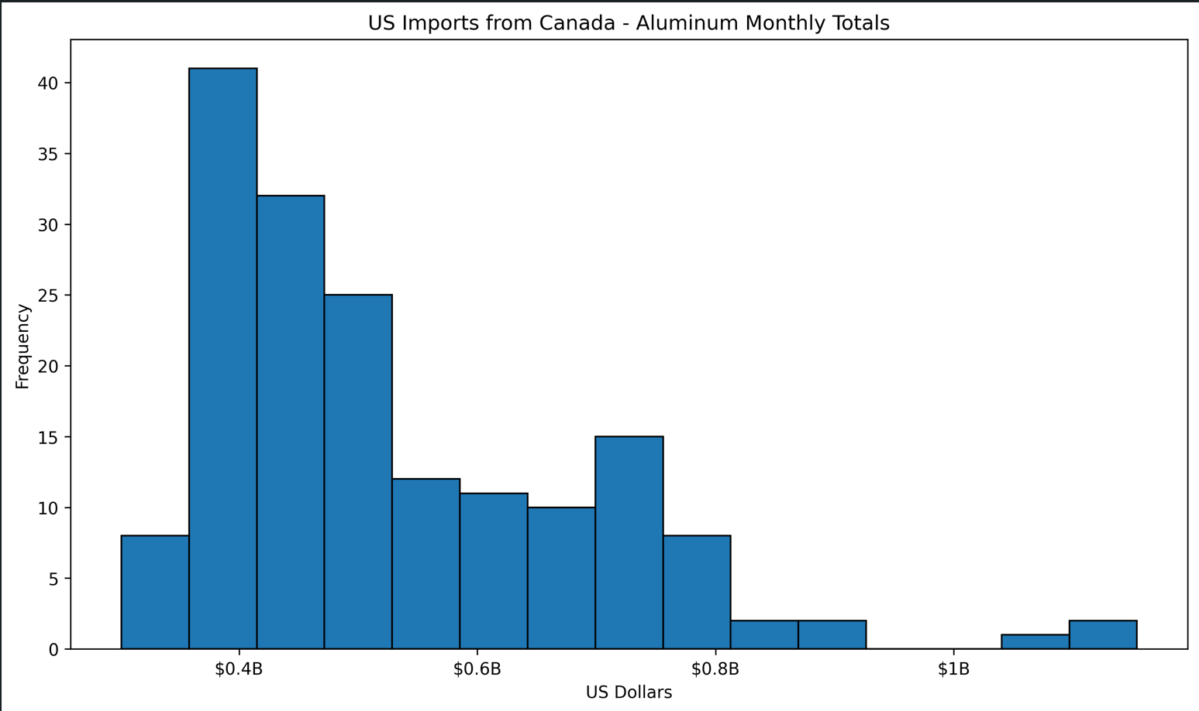
A similar pattern appears in U.S. imports from Canada, although at much larger dollar values. Aluminum imports totaled about $89.23 billion, with an average monthly value of $527.96 million and a maximum monthly value of roughly $1.15 billion. Steel imports totaled about $3.87 billion, with an average monthly value of $22.89 million and a maximum monthly value of about $58.08 million. Automotive imports were much larger than either of those sectors, totaling about $476.21 billion, with an average monthly value of $2.82 billion and a maximum monthly value of about $4.71 billion. These figures show not only how much larger the import side is than the export side, but also how much more sensitive the larger sectors may be to major economic or policy disruptions over time.
Figure 2
U.S. Imports from Canada – Auto Monthly Trend
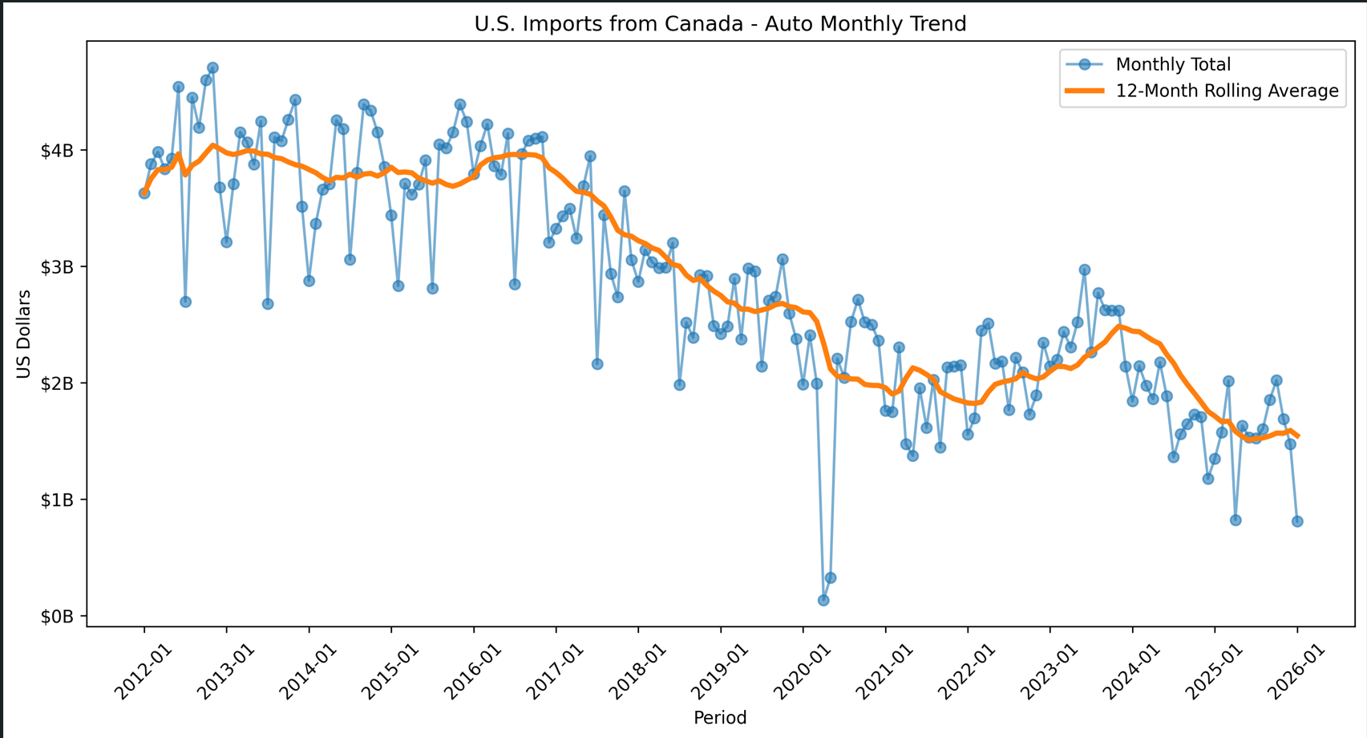
The monthly trend lines provide additional context because they show how trade changed over time rather than only where values were concentrated. For U.S. exports to Canada, the automotive sector showed the largest swings in monthly dollar values, while aluminum and steel moved in narrower ranges. The 12-month rolling averages help smooth short-term volatility and show the broader direction of trade over time. In the export data, aluminum and steel both appear to have periods of decline followed by recovery, while auto exports show larger swings across the full sample period. These broader movements suggest that short-term observations alone would not fully capture the trend in bilateral trade.
Figure 3
U.S. Exports to Canada – Auto Monthly Trend
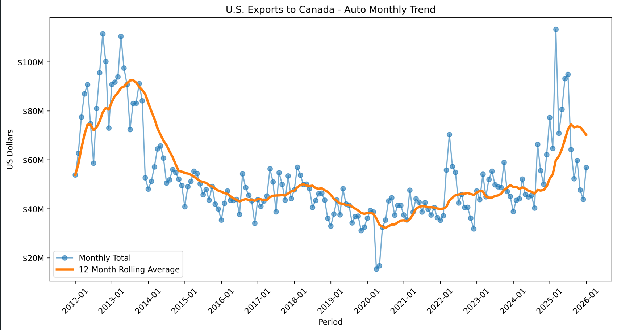
Figure 4
U.S. Exports to Canada – Steel Monthly Trend
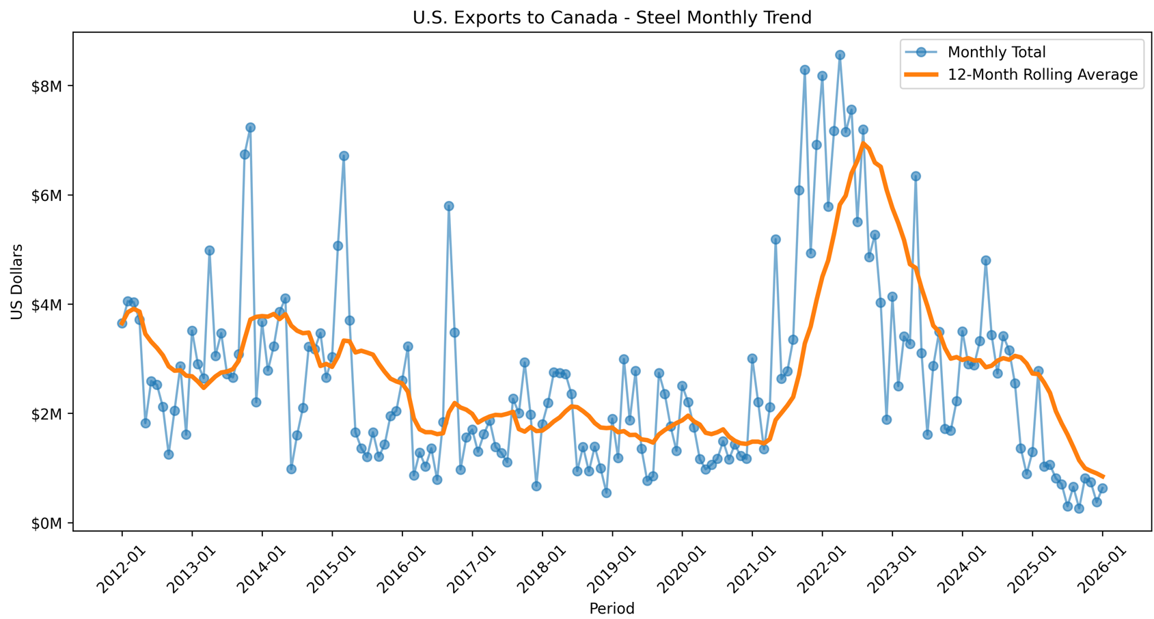
The Canadian annual import summaries are especially important because they connect directly to the project’s trade-diversion question. Canadian annual automotive imports were the largest of the three sectors, totaling about $429.52 billion from 2012 through 2025, with an average annual total of about $30.68 billion. Aluminum imports totaled about $30.31 billion, with an average annual total of $2.17 billion, while steel imports totaled about $10.55 billion, with an average annual total of $753.27 million. These totals again show that auto trade dominates in overall scale, but they also show that aluminum and steel remain important because they are directly tied to the tariff-related policy questions in this study.
In aluminum, U.S. imports were larger than non-U.S. imports for most of the earlier years, but the difference narrowed substantially over time. By 2025, non-U.S. aluminum imports were above U.S. aluminum imports. In the automotive sector, the United States remained the larger source for most years, but non-U.S. imports rose over time and moved much closer to the U.S. level by the end of the series. Steel shows the clearest visual shift. In several later years, non-U.S. steel imports exceeded U.S. steel imports, suggesting that Canada’s sourcing pattern changed meaningfully over time. While these descriptive results do not prove causation, they are consistent with the possibility that tariff periods were associated with some reallocation of trade toward non-U.S. suppliers. Figures 5-7 help visualize the above.
Figure 5
Canadian Imports (U.S. vs Non-US) - Aluminum (Annual Totals)
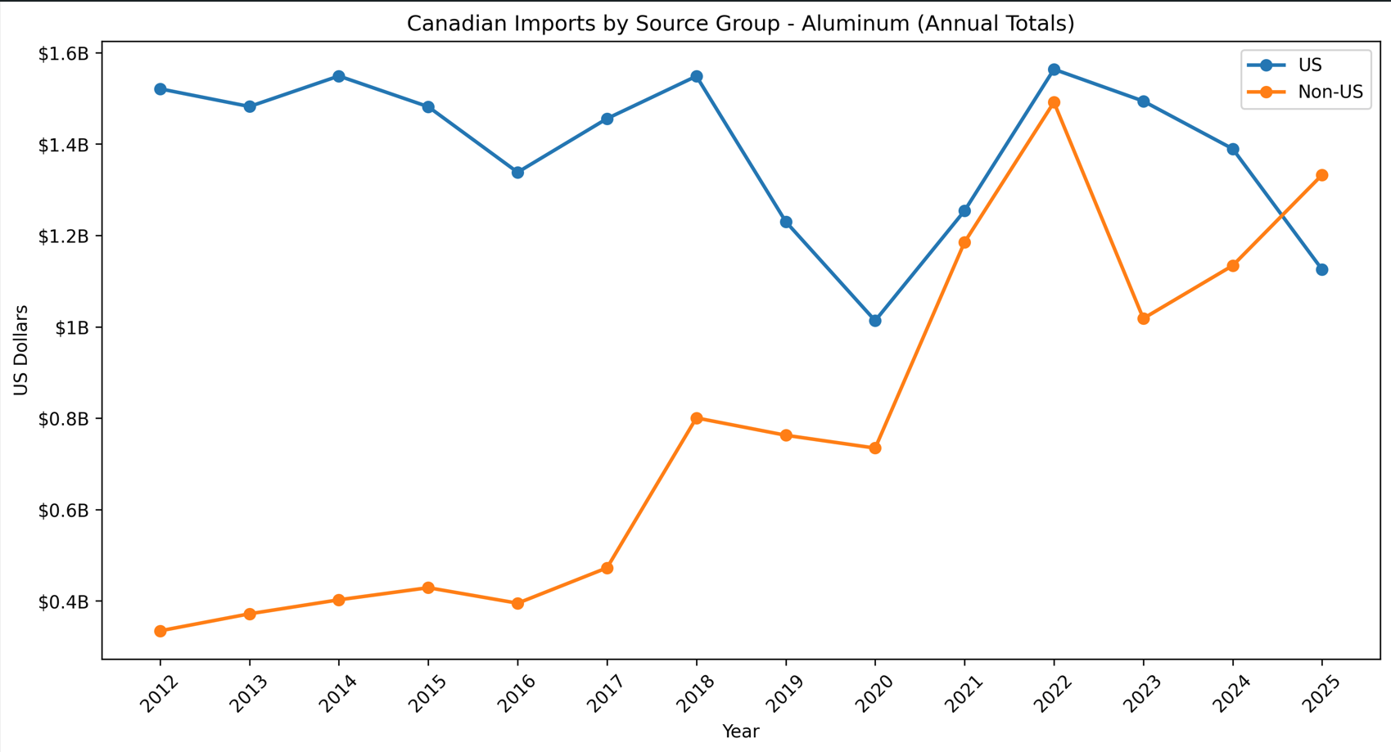
Figure 6
Canadian Imports (U.S. vs Non-US) - Auto (Annual Totals)

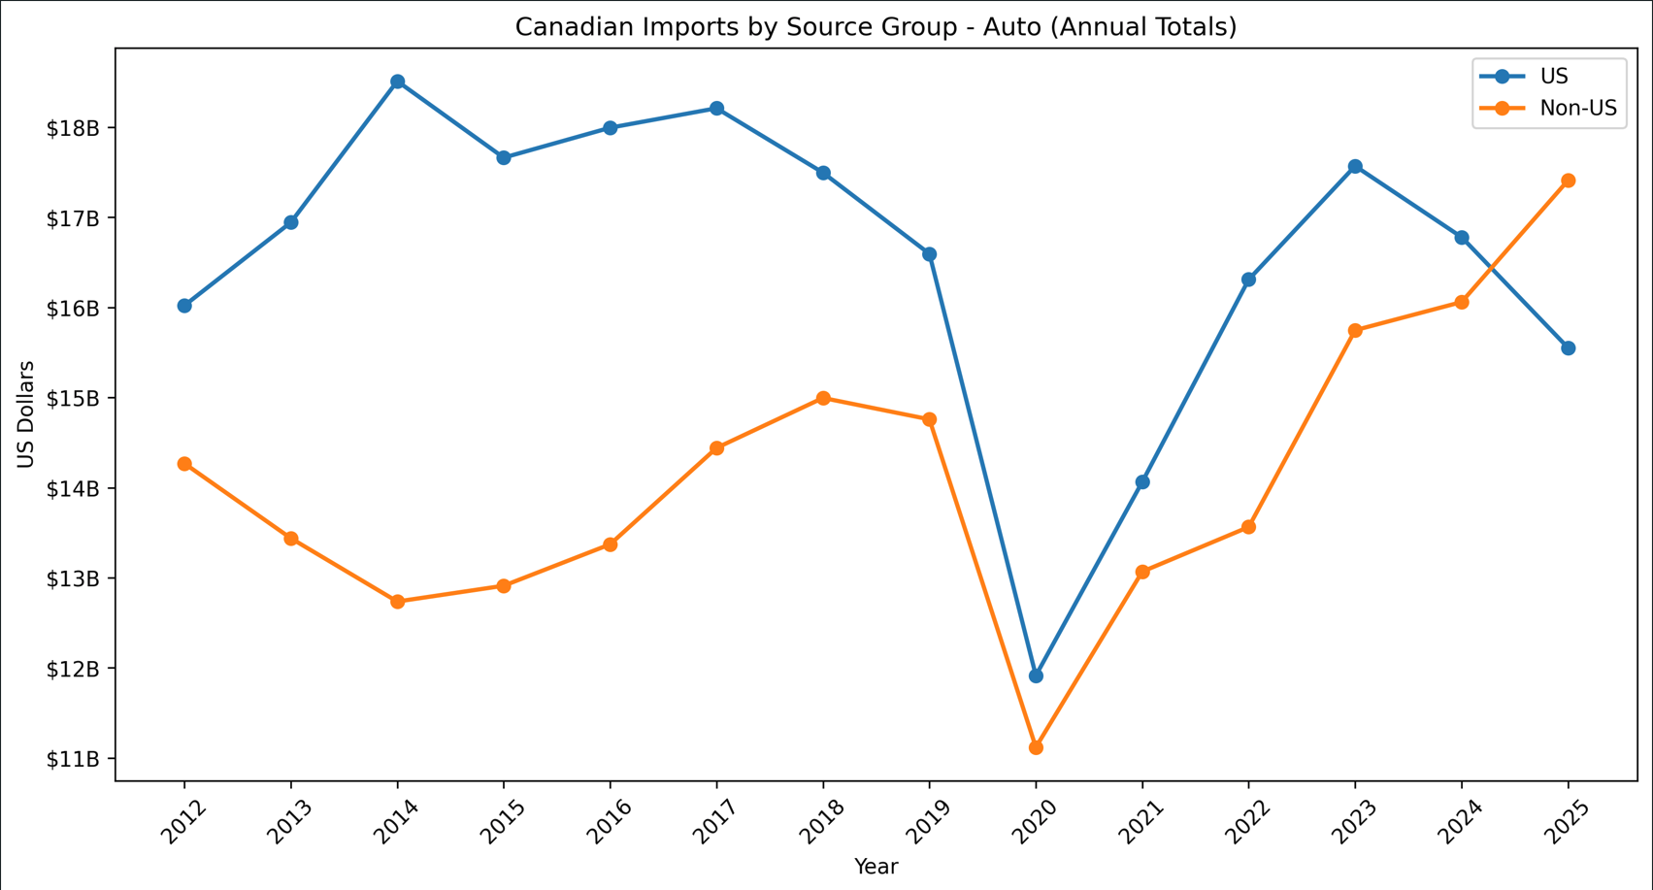
Figure 7
Canadian Imports (U.S. vs Non-US) - Steel (Annual Totals)
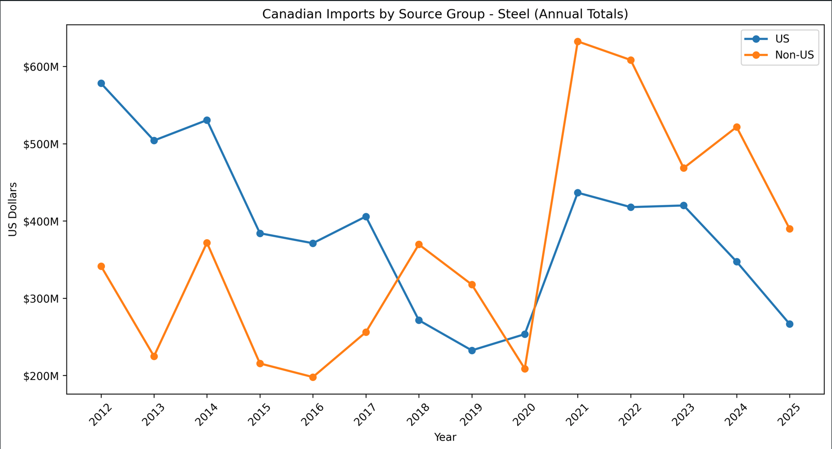
Overall, the descriptive statistics show three important findings. First, the automotive sector dominates the selected tariff-exposed groups in total dollar scale. Second, the monthly trade data are not evenly distributed and instead show skewness, volatility, and occasional large spikes rather than a clear normal pattern. This is important because it supports the use of the Mann-Whitney U test in the next stage of the analysis. That test is appropriate here because it does not require the trade values to be normally distributed and is better suited for comparing tariff and non-tariff periods when the data contain outliers and uneven spread. Third, the annual Canadian source-group trends suggest that U.S. and non-U.S. suppliers did not move in the same way over time, especially in aluminum and steel. Together, these descriptive findings provide the baseline context for the formal hypothesis tests that follow.
Research Question 1: Canada’s Imports from the United States
RQ1 asked whether Canada's average monthly imports from the United States declined during tariff periods compared with non-tariff periods. Two statistical methods were applied to evaluate this question: the Mann-Whitney U test and ordinary least squares regression. Both used monthly U.S. export values to Canada for each of the three sector groups, reflecting Canada's imports from the United States during periods when counter-tariff actions were active.
Figure 8
Mann-Whitney Summary RQ1 Results (Terminal)
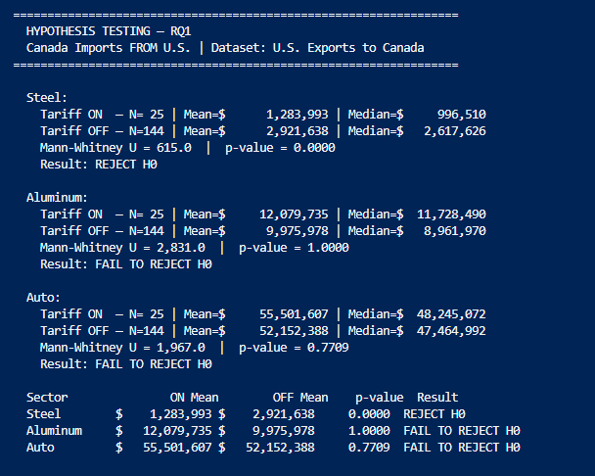
Figure 9
OLS Regression Summary RQ1 Results (Terminal)
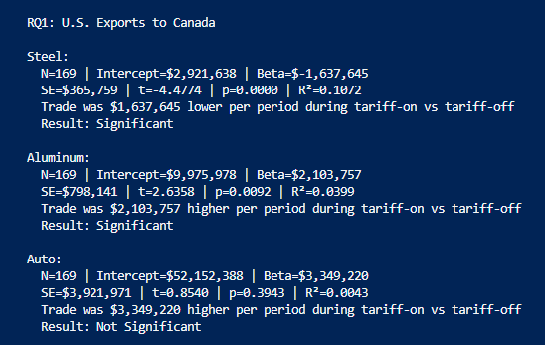
Results varied meaningfully across sectors. For steel, the Mann-Whitney U test produced a statistic of 615.0 and a p-value of less than 0.001, leading to rejection of the null hypothesis. The mean monthly export value during tariff-on periods was approximately $1.28 million compared with $2.92 million during tariff-off periods. The OLS regression supported this finding, estimating a tariff-period beta of negative $1.64 million per month, which was also statistically significant (p < 0.001, R² = 0.107). Both methods indicate that steel exports to Canada were meaningfully lower during counter-tariff periods.
For aluminum and automobiles, the results tell a different story. The counter-tariff actions do not appear to have materially reduced U.S. exports in either sector. For aluminum, the Mann-Whitney U test produced a p-value of 1.000, and the OLS regression estimated a positive beta of approximately $2.10 million per month (p = 0.009), meaning aluminum exports to Canada were higher on average during tariff-active periods. For automobiles, the Mann-Whitney U test produced a p-value of 0.771, and the OLS regression estimated a positive but statistically insignificant beta of approximately $3.35 million per month (p = 0.394). In both cases, the null hypothesis could not be rejected.
Overall, the null hypothesis for RQ1 was rejected for steel only. The mixed results suggest that Canada's counter-tariff actions were not uniformly associated with reduced U.S. exports across all three sectors, and that other factors likely continued to drive aluminum and automobile trade volumes during the tariff periods studied.
Research Question 2: Canada's Imports from Non-U.S. Countries
RQ2 asked whether Canada's imports from non-U.S. countries increased during tariff periods, which would be consistent with trade diversion away from U.S. suppliers in response to counter-tariff actions. The Mann-Whitney U test and OLS regression were both applied using annual Canadian import data by source country. Unlike RQ1, this analysis relies on annual rather than monthly data, resulting in only three tariff-on observations and eleven tariff-off observations per sector. Combined with the low R² values observed across most sectors, these constraints limit the statistical power of both tests and mean that findings should be interpreted with caution, as the tariff dummy explains only a small portion of the variation in non-U.S. import values.
Figure 10
Mann-Whitney Summary RQ2 Results (Terminal)

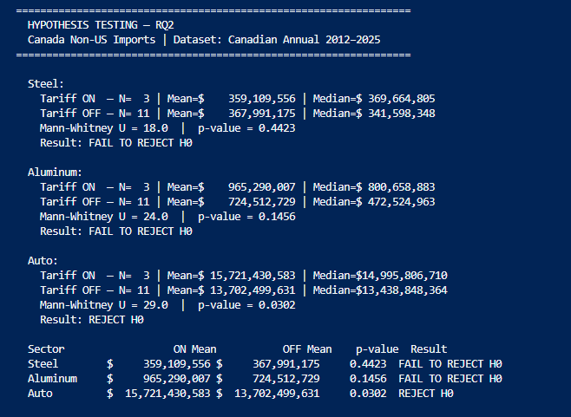
Figure 11
OLS Regression Summary RQ2 Results (Terminal)
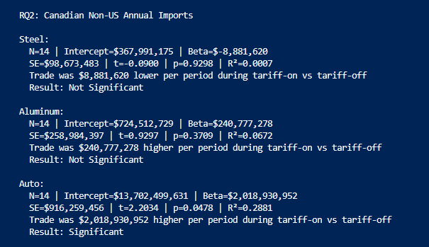
For steel, neither test detected a meaningful increase in non-U.S. imports during tariff periods. The Mann-Whitney U test produced a p-value of 0.442, and the OLS regression estimated a slightly negative beta of $8.88 million per year (p = 0.930, R² = 0.001), indicating that the tariff dummy explains virtually none of the variation in the data.
For aluminum, results were directionally positive but did not reach statistical significance. The Mann-Whitney U test produced a p-value of 0.146, and the OLS regression estimated a positive beta of approximately $240.78 million per year (p = 0.371, R² = 0.067). Given the limited observations and low R², this finding is worth noting but cannot be treated as conclusive.
For automobiles, the null hypothesis was rejected. The Mann-Whitney U test produced a p-value of 0.030, and the OLS regression estimated a positive beta of approximately $2.02 billion per year (p = 0.048, R² = 0.288). Even so, the R² value indicates that the tariff period alone accounts for less than a third of the variation, reinforcing that multiple economic factors were at play.
Overall, the null hypothesis for RQ2 was rejected for automobiles only. The limited data points and generally low R² values across all three sectors mean these results are best understood as suggestive rather than definitive evidence of trade diversion.
Research Question 3: Canada's Exports to the United States
RQ3 asked whether Canada's exports to the United States declined during tariff periods compared with non-tariff periods. This question examines the other direction of the trade relationship, looking at how tariff escalation may have affected Canada's ability to export into the U.S. market. The Mann-Whitney U test and OLS regression were both applied to monthly U.S. import values from Canada for each of the three sector groups. Like RQ1, this analysis benefits from a full monthly dataset with 25 tariff-on observations and 144 tariff-off observations per sector, providing considerably more statistical power than the annual data used in RQ2.
Figure 12
Mann-Whitney Summary RQ3 Results (Terminal)
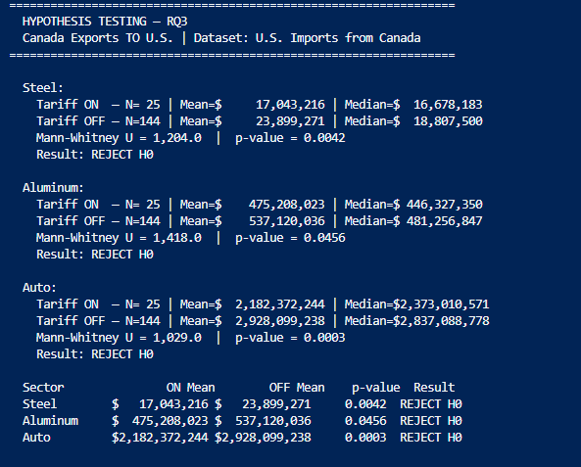
Figure 13
OLS Regression Summary RQ3 Results (Terminal)

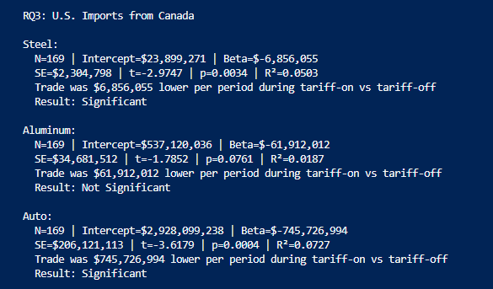
For steel, the Mann-Whitney U test produced a statistic of 1,204.0 and a p-value of 0.004, leading to rejection of the null hypothesis. The mean monthly value during tariff-on periods was approximately $17.04 million compared with $23.90 million during tariff-off periods. The OLS regression estimated a negative beta of approximately $6.86 million per month (p = 0.003, R² = 0.050), supporting the conclusion that Canadian steel exports to the United States were lower during tariff-active periods.
For aluminum, the Mann-Whitney U test produced a statistic of 1,418.0 and a p-value of 0.046, leading to rejection of the null hypothesis. The mean monthly value during tariff-on periods was approximately $475.21 million compared with $537.12 million during tariff-off periods. However, the OLS regression estimated a negative beta of approximately $61.91 million per month but did not reach statistical significance (p = 0.076, R² = 0.019). The mixed signals between the two methods, combined with the low R² value, suggest that while there is some evidence of a decline in Canadian aluminum exports during tariff periods, the relationship is not as clearly defined as it is for steel.
For automobiles, both methods produced strong results. The Mann-Whitney U test produced a statistic of 1,029.0 and a p-value of less than 0.001, and the OLS regression estimated a negative beta of approximately $745.73 million per month (p < 0.001, R² = 0.073). The mean monthly value during tariff-on periods was approximately $2.18 billion compared with $2.93 billion during tariff-off periods. Both methods indicate that Canadian automotive exports to the United States were meaningfully lower during tariff-active periods, and the auto sector's large dollar values make this the most economically significant finding across all three RQs.
Overall, the null hypothesis for RQ3 was rejected across all three sectors, making it the strongest result in the study. While the R² values are modest, indicating that tariff periods alone do not explain all variation in trade as stated throughout the paper, the consistency of the directional finding across steel, aluminum, and automobiles suggests that tariff escalation was associated with a broad-based weakening of Canada's exports to the United States during the periods being analyzed.
Predictive Forecast: Canada's Exports to the United States
To complement the hypothesis testing results, a two-scenario predictive forecast was developed to project how Canada's exports to the United States may trend over the 24 months from 2026 through 2027. The forecast is built on a linear trend fit to the pre-tariff baseline period of January 2012 through February 2018, which captures the historical trajectory of trade before either tariff episode began. Two scenarios are projected forward from January 2026. Scenario 1 assumes current tariffs remain in place and applies the OLS beta estimated in RQ3 as a downward adjustment to the baseline trend. Scenario 2 assumes tariffs are removed and projects the baseline trend forward without any tariff adjustment. The gap between the two scenarios represents the estimated trade value associated with continued tariff activity in each sector.
For steel, the forecast projects that if current tariffs remain in place, monthly export values will stabilize in the range of approximately $12.47 million in early 2026 and trend gradually toward $13.02 million by early 2028. If tariffs are removed, the model projects values in the range of approximately $19.33 million rising to $19.87 million over the same period. The gap between the two scenarios of roughly $6.86 million per month reflects the OLS beta estimated for steel in RQ3 and represents the estimated cost of continued tariffs on Canadian steel exports to the United States.
Figure 14
Forecast Canada Exports Steel
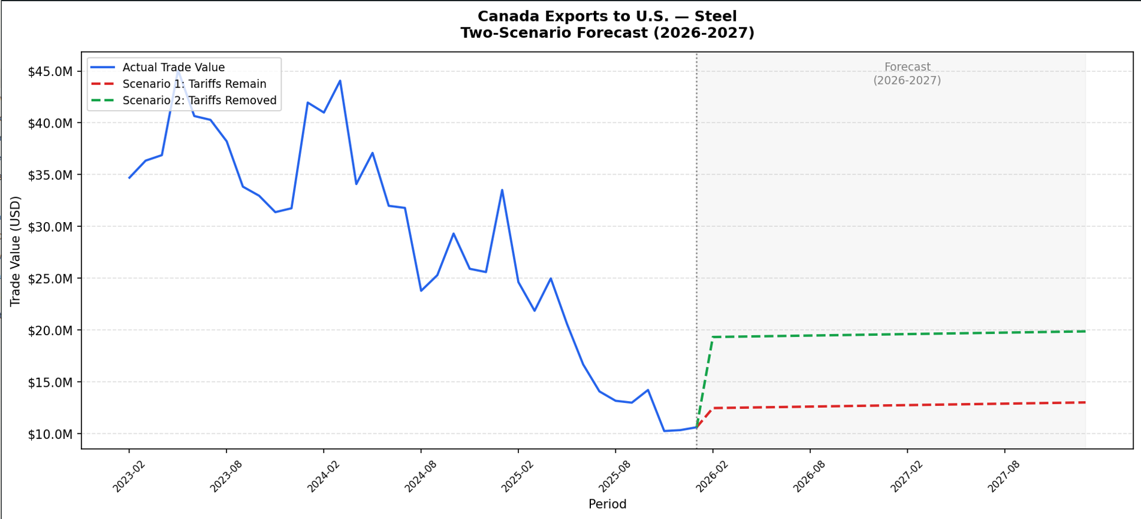
For aluminum, the forecast projects monthly export values of approximately $510.38 million under the tariffs-remain scenario in early 2026, rising gradually to approximately $534.06 million by early 2028. Under the tariffs-removed scenario, values are projected to range from approximately $572.29 million to $595.97 million over the same period. The gap of approximately $61.91 million per month again reflects the RQ3 OLS beta for aluminum. It is worth noting that the OLS regression for aluminum in RQ3 did not reach statistical significance, so this forecast should be interpreted with more caution than the steel and automobile projections.
Figure 15
Forecast Canada Exports Aluminum
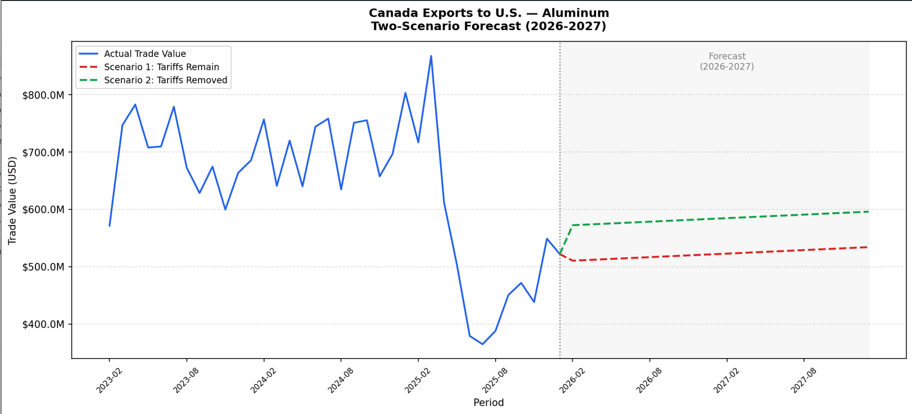
For automobiles, the forecast produces the largest projected gap between the two scenarios, which is consistent with the auto sector's dominant size throughout this study. Under the assumption that tariffs remain in place, monthly export values are projected at approximately $1.80 billion in early 2026 and decline gradually to approximately $1.59 billion by early 2028, reflecting the negative trend embedded in the historical baseline. Under the assumption that tariffs are removed, values are projected at approximately $2.54 billion in early 2026 and decline to approximately $2.34 billion by early 2028. The difference between the two scenarios of roughly $745 million per month is the largest estimated tariff impact of any sector in this study and gives a sense of how much continued tariff activity could weigh on Canadian automotive exports to the United States over the next two years. Given how central the auto sector is to cross-border trade between the two countries, this gap is the most consequential finding of the entire forecast section of analysis.
Figure 16
Forecast Canada Exports Auto
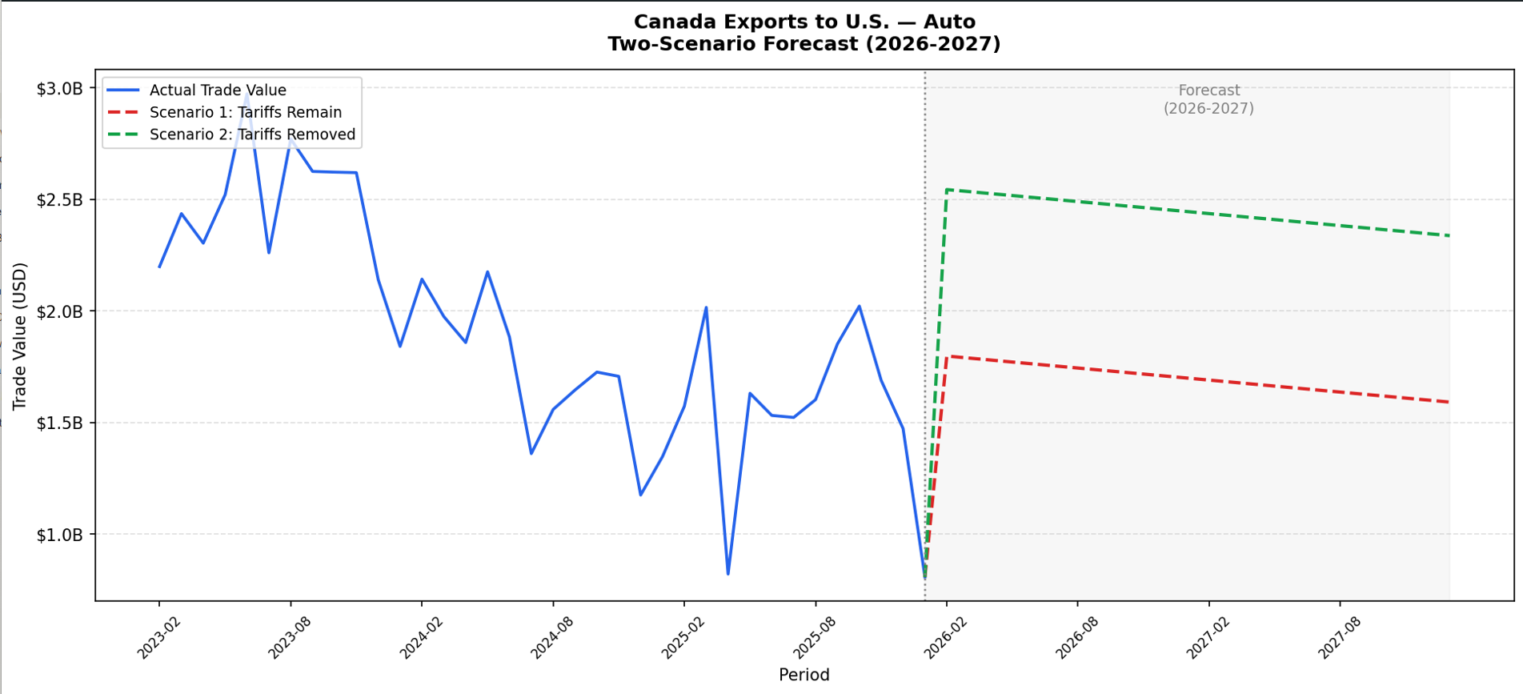
Across all three sectors, the forecast results reinforce the pattern observed in the hypothesis testing. Tariff removal is consistently associated with higher projected trade values, and the magnitude of the difference varies meaningfully by sector. These projections are not predictions of what will happen, but rather a structured, data-driven illustration of what the historical trend and estimated tariff effect together suggest about the two scenarios. As with all results in this study, they should be interpreted as evidence of association rather than certainty, and real-world outcomes will depend on a wide range of economic, political, and supply chain factors that this model does not capture. The forecasts were run only on this side of the trade due to how the hypothesis testing results came back.
Conclusion
This study reviewed whether two tariff episodes between the United States and Canada produced statistically detectable changes in bilateral trade flows across the steel, aluminum, and automobile sectors. Using monthly and annual trade data spanning January 2012 through January 2026, three research questions were tested using Mann-Whitney U tests, ordinary least squares regression, and a two-scenario predictive forecast for tariffs being on or off. The results were mixed across sectors and research questions, which is an important finding in itself.
For RQ1, the null hypothesis was rejected for steel only, indicating that Canada's counter-tariff actions were associated with a statistically significant decline in U.S. steel exports to Canada during tariff-active periods. Aluminum and automobile exports from the United States to Canada did not show a statistically meaningful decline during those same periods, suggesting that counter-tariff actions did not uniformly reduce demand for U.S. goods across all tariff-exposed product categories.
For RQ2, the null hypothesis was rejected for automobiles only, providing some evidence that Canada increased non-U.S. sourcing for automotive products during tariff periods, which is consistent with trade diversion behavior. Steel and aluminum did not show statistically significant evidence of diversion, though the limited number of annual data points and low R² values across all three sectors mean these findings should be treated as suggestive rather than conclusive. The data constraints in RQ2 remain the most important caveat of the entire study. It does help confirm findings in RQ3.
For RQ3, the null hypothesis was rejected across all three sectors, making it the most consistent finding of the study. Canadian exports of steel, aluminum, and automobiles to the United States were all lower on average during tariff-active periods compared with non-tariff periods. The automobile sector showed the largest absolute difference, with monthly export values averaging roughly $745 million lower during tariff periods, reinforcing how deeply tariff escalation can affect a sector as integrated and large as the North American automotive trade.
Taken together, the findings suggest that tariff escalation between the United States and Canada has been associated with measurable changes in trade flows, particularly in Canada's exports to the United States. However, the modest R² values observed throughout the regression analysis are a consistent reminder that tariff periods alone do not explain the full picture. Exchange rates, inflation, supply chain disruptions, the COVID-19 pandemic, and broader macroeconomic conditions all contributed to the variation observed in the data. The results of this study are therefore best understood as evidence of association between tariff periods and trade outcomes rather than proof that tariffs were the sole or primary driver of any observed change.
Recommendations
Based on the findings of this study, several recommendations are offered for organizations, analysts, and policymakers operating within the U.S.-Canada trade relationship across the steel, aluminum, and automobile sectors.
The first recommendation is for automotive sector stakeholders to closely monitor the trajectory of Canada's exports to the United States. Of all three sectors studied, automobiles showed the most consistent and economically significant evidence of tariff impact. The RQ3 findings indicated that Canadian automotive exports to the United States were on average roughly $745 million lower per month during tariff-active periods compared with non-tariff periods, a difference that was statistically significant under both the Mann-Whitney U test and OLS regression. This alone makes the automotive sector the most consequential finding of the study in absolute dollar terms.
Supporting this concern, the RQ2 results suggest that Canada's automotive supply chain may already be responding to tariff pressure by shifting sourcing away from U.S. suppliers toward non-U.S. alternatives. While that finding came with data limitations, it points in a direction that is consistent with longer-term structural change in how automotive goods move across the border. Looking forward, the predictive forecast reinforces this picture. The projected gap between the tariffs-remain and tariffs-removed scenarios in the automotive sector is approximately $745 million per month, the largest of any sector in this study, and that gap persists across the entire two-year forecast horizon. Organizations operating in the automotive supply chain should consider whether their current sourcing and distribution strategies adequately account for the possibility that tariff conditions could persist or escalate further, and should treat the combination of these three findings as a signal worth taking seriously.
The second recommendation is for organizations in the steel sector to treat tariff risk as a recurring operational consideration rather than an isolated event. The findings for RQ1 and RQ3 both showed statistically significant associations between tariff periods and reduced steel trade in both directions, making steel the sector most consistently affected across the study. Companies that source or sell steel across the U.S.-Canada border would benefit from maintaining flexible supplier relationships and monitoring tariff policy developments closely, as the two episodes studied here suggest that disruptions can emerge with relatively little warning and produce measurable impacts on trade volumes.
The third recommendation is directed at analysts and researchers building on this work. The data constraints in RQ2 were the most significant limitation of this study, and future research would benefit from access to more granular monthly data on Canadian imports by source country across a longer historical period. A larger dataset would increase statistical power considerably and allow for more definitive conclusions about trade diversion behavior. Additionally, incorporating inflation adjustments and broader economic controls into the regression framework would help isolate the tariff effect more cleanly from the many other forces that influence trade volumes simultaneously.
The fourth recommendation is for policymakers on both sides of the border to consider the compounding nature of tariff escalation when evaluating trade policy decisions. The forecast results across all three sectors consistently show a meaningful gap between the tariffs-remain and tariffs-removed scenarios, and while these projections carry uncertainty, they illustrate in concrete dollar terms how sustained tariff activity may continue to weigh on bilateral trade. Given how deeply integrated the two economies are, particularly in the automotive sector, policy decisions that reduce trade uncertainty are likely to produce benefits that extend well beyond the directly affected product categories.

References
May, B. (2025). The global implications of more extreme US tariffs. Economic Outlook.
Liu, Y. (2026). A literature review of the U.S.-Canadian trade relations and scenarios on impacts of tariff changes proposed. Academic Journal of Management and Social Sciences, 14(2).
Ruiz Estrada, M. A., Koutronas, E., & Quali, H. (2025, March). The tariffs war between U.S. vs. Canada: Winners and losers [Preprint]. SSRN.
Trefler, D. (2001, May). The long and short of the Canada-U.S. Free Trade Agreement (NBER Working Paper No. 8293). National Bureau of Economic Research.
Canada, Department of Finance. (2025, June 19). Countermeasures in response to unjustified tariffs on Canadian steel and aluminum products. Government of Canada. https://www.canada.ca/en/department-finance/programs/international-trade-finance-policy/measures-steel-aluminum-businesses/countermeasures-response-unjustified-tariffs-canadian-steel-aluminum-products.html
Canada, Department of Finance. (2025, December 22). Complete list of U.S. products subject to counter-tariffs. Government of Canada. https://www.canada.ca/en/department-finance/programs/international-trade-finance-policy/canadas-response-us-tariffs/complete-list-us-products-subject-to-counter-tariffs.html
U.S. International Trade Commission. (2026). U.S. merchandise trade statistics [Data set]. USITC DataWeb. https://dataweb.usitc.gov/
Government of Canada. (2026). Canadian international merchandise trade [Data set]. Statistics Canada Trade Data Online. https://www150.statcan.gc.ca/n1/pub/71-607-x/2018011/tdo-dce-eng.htm
Towe, C. (2025, July 30). The impact of the trade war on Canada. Econofact. https://econofact.org/the-impact-of-the-trade-war-on-canada

